**Cereal Killer 05**

***Reverse***

**Challenge:**

We think Dr. Geschichter of Lytton Labs likes to use his favorite monster cereal as a password for ALL of his accounts! See if you can figure out what it is, and keep it handy! Choose one of the binaries to work with.

Enter the answer as flag{WHATEVER-IT-IS}.

Attached - Windows and Linux Binaries

**Approach:**

The easiest one actually. We just open it up on ghidra and see this:

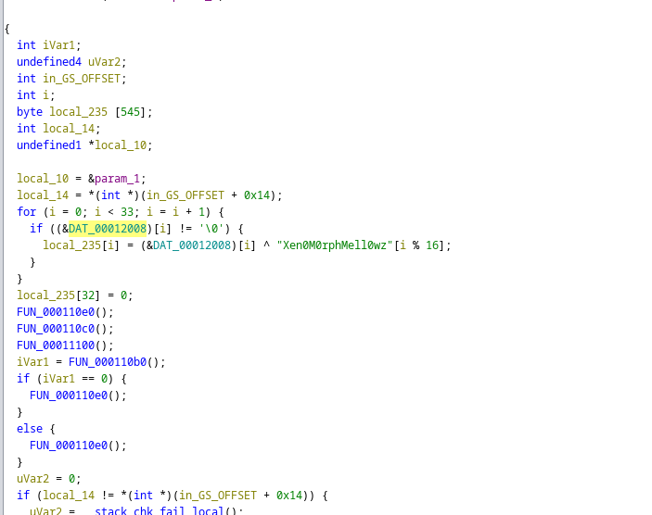

We just craft the local_235 array based on the condition given and get the flag as:

**Flag: flag{XENO-DO-DO-DO-DO-DO-DOOOOO}**

Congrats!!

Happy Hacking!